**GOOD TIMES PRODUCTIONS**

**Media Contact:**

Matthew Wilson

Good Times Productions / Greater Thinking Music Group

404.316.0621

[matt@gtmusicgroup.com](mailto:matt@gtmusicgroup.com)

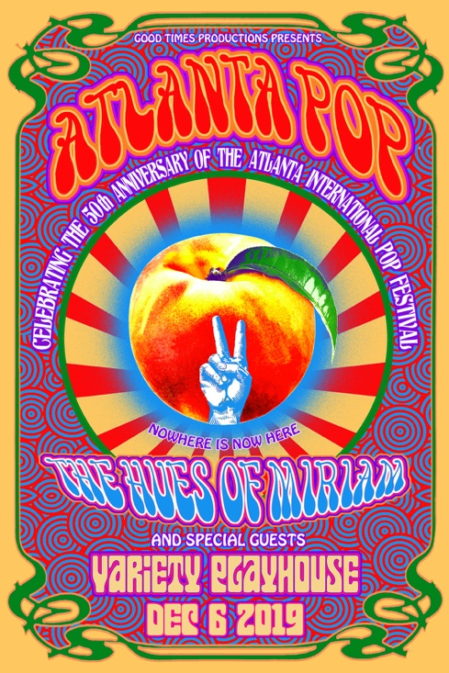

**ATLANTA POP**

**ATLANTA POP Celebrating the 50th Anniversary of the Atlanta International Pop Festival at the Variety Playhouse on December 6**

**TICKETS ON SALE SEPTEMBER 20**

**ATLANTA (September 13, 2019)** – Good Times Productions and The Fox Theatre are proud to announce **Atlanta Pop: Celebrating the 50th Anniversary of the Atlanta International Pop Festival** – taking place on **December 6** at the **Variety Playhouse.** The concert – featuring an eclectic group of (mostly) Georgia-based musicians – will celebrate and pay tribute to the Atlanta International Pop Festival. The original event, considered Atlanta’s first music festival, was organized by a 17-person promotional team led by legendary Atlanta promoter, Alex Cooley. Held at the Atlanta International Raceway in Hampton, Georgia on July 4-5, 1969, the concert was attended by over 140,000 people and featured superstars such as Jimi Hendrix; Janis Joplin; Led Zeppelin; Joe Cocker; Booker T and the M.G.’s; and Credence Clearwater Revival. The following year, over 300,000 people descended upon Byron, Georgia for the follow-up three-day festival, which included Allman Brothers Band, BB King, Col. Bruce Hampton’s Hampton Grease Band and The Jimi Hendrix Experience (the largest American audience ever for Hendrix). Honoring the legacy of the two Atlanta International Pop Festivals, **Atlanta Pop** will feature Atlanta-based super group, **The Hues of Miriam** – comprised of **Jacob Deaton** (Col. Bruce Hampton), **Nick Johnson** (Randall Bramblett), **Kevin Scott** (Jimmy Herring, John McLaughlin), **Darren Stanley** (Jimmy Herring), **Matt Slocum** (Aquarium Rescue Unit, Railroad Earth) and **Duane Trucks** (Widespread Panic) – all Col. Bruce Hampton alumni. The material for **Atlanta Pop** will be selected from the catalogs of the artists that performed at the original 1969 and 1970 events. Joining the house band will be a cross-section of special guests, including **Brandon “Taz” Niederauer, Charlie Starr** (Blackberry Smoke), **Jennifer Hartswick** (Trey Anastasio Band), **Jeff Mosier, Denny Walley** (Frank Zappa, Captain Beefheart), **T. Hardy Morris, Sven Papien** (Magpie Salute, The Black Crows), **Cicada Rhythm, Thomas Johnson, Carter King, and Daniel Womack** (Futurebirds), **Cody Matlock, and many more**. The concert will pay homage to the “southern Woodstock” – an event deserving of recognition for its immeasurable contributions to the historic fabric of Georgia and American music, generally. At the same time, **Atlanta Pop** will spotlight two dozen of the most accomplished Georgia-based (or Georgia-linked) rock, folk, jazz and blues musicians in the contemporary live scene. The event promoters, together with their non-profit partners – the Georgia Music Foundation and Fox Theatre Institute – aim to carry forward the inspiring legacy of Alex Cooley and the Atlanta International Pop Festival fifty years after the first notes were played at the Raceway in 1969.

Tickets, on-sale now at zeromile.com, the Variety Playhouse Box Office and (404)-524-7354, start at $30.00, plus applicable fees.

###

**About Good Times Productions**

Good Times Productions is an Atlanta-based production company. The company, owned by partners, Matthew Wilson (Greater Thinking Music Group), Steve Lopez (Widespread Panic), and Kit Blanchard (PRISM), produced Hampton 70 – the Col. Bruce Hampton 70th birthday celebration – in 2017.

**About the Fox Theatre**  
The Fox Theatre is one of Atlanta’s premier venues for live entertainment. Listed as No. 1 non-residency venue worldwide for the decade by Billboard Magazine, the Fox Theatre was most recently named as one of the 2018 “Top Stops Worldwide” by Venues Now magazine and landed in the top three of Pollstar magazine’s 2018 Worldwide Ticket Sales. Other notable accolades include nods for 2017 “Theatre of the Year” by the International Entertainment Buyers Association, Rolling Stone magazine’s “The Best Big Rooms in America” as part of their “Venues That Rock” series (2013) and the 2011 “Outstanding Historic Theatre of the Year” award by the League of Historic American Theatres. For the past decade, the Fox Theatre has consistently ranked in the top three non-residency theatres in North America for gross ticket sales by industry trade magazines, Pollstar, Billboard and Venues Now. The Fox Theatre has the No. 1 social media presence for any theatre or performing arts center in North America (2,000-5,000 seats) and for any Georgia venue according to the “Social Media Power 100” compiled by Venues Now magazine. With 4,665 seats in the theatre, the Fox hosts 250 performances a year, from rock concerts and Broadway productions to ballets, comedy and movies, attracting 500,000 visitors annually. In addition, the Fox hosts wedding receptions, trade shows, corporate meetings and association functions in its fabulous ballrooms, lounge and outdoor terrace.

As a 501(c)(3) nonprofit arts organization, the Fox Theatre stands today as a fiercely protected landmark and a nationally acclaimed theater and is celebrating its 90th year in 2019. The Fox Theatre proudly acknowledges its partners for their generous support: Coca-Cola, Lexus, Georgian Terrace Hotel, Georgia Natural Gas, Atlanta Beverage-Yuengling, Regions, Grady Health System and Whole Foods Market. Tickets for all events are available at the Fox Theatre Ticket Office, online at [FoxTheatre.org](http://secure-web.cisco.com/1S2jEAVuTQQY4zWFHz4aTMIvStJrwDoyE_JQ7KNP-19fb920xG171eQnfmMCPIXTPAVktkMerQwDBSwXCZECOIuKNQPIZNAqlt7iYxZ6SihwCVW2JfycI-x6PEYWx-ElJNhpTlG_pkXCagEsM1CtZIQQt1vC_AKZcUATLpEukZdat1xKYK8xXoXo5qH49_ObgxYhCB5AAJmNma8MHzycY9cscp_17KBLi5AmNSjSOOlJToJ6AUT9wBXoU2t8SiCtZlw7DpcbOfo4dsTb9eHdBTxSGQ-stb6suHTe1BFsyKGnM-vmsdcsQgLAx4Ae0O7RHvrX5LPuEv8zDP16kvNs_VA/http%3A%2F%2Fwww.foxtheatre.org%2F) or toll free at 855-285-8499. For group sales information contact the Fox Theatre at 404- 881-2000, or visit the Fox Theatre website at [foxtheatre.org](http://secure-web.cisco.com/1S2jEAVuTQQY4zWFHz4aTMIvStJrwDoyE_JQ7KNP-19fb920xG171eQnfmMCPIXTPAVktkMerQwDBSwXCZECOIuKNQPIZNAqlt7iYxZ6SihwCVW2JfycI-x6PEYWx-ElJNhpTlG_pkXCagEsM1CtZIQQt1vC_AKZcUATLpEukZdat1xKYK8xXoXo5qH49_ObgxYhCB5AAJmNma8MHzycY9cscp_17KBLi5AmNSjSOOlJToJ6AUT9wBXoU2t8SiCtZlw7DpcbOfo4dsTb9eHdBTxSGQ-stb6suHTe1BFsyKGnM-vmsdcsQgLAx4Ae0O7RHvrX5LPuEv8zDP16kvNs_VA/http%3A%2F%2Fwww.foxtheatre.org%2F). Please stay connected with the Fox Theatre on [Instagram](https://secure-web.cisco.com/13mBNcwYloOG3zVBkeOF2q6zdtwMr82fdCLrETisbk2gT71szHJELudn8oqzTjNWnrvo8sEKvmMun4541f58BIWQp8WoTd65A2YIF_3iP_-q6grkfHsl4pQ5mOTUC0T77GT6V5LTGZrXuOwGzmlL3TDxNCD9P_PA7m1JWsQD0Zhko1x21WFlY9MEYjcucQEG-o9_L1t_0tghiqKHgP6QE0kjTMpm0857Qyr0WGVZ-qMb-mILJNlceuaHJhp6Ueeat7Jnn_x38bOq7vyJ0lqnjU4EFQDdgLeNxcjkhZg1a5bqUetosAY66An96Iz3Ea4gN8oZcL_WXdxI7vV3JQSPC5w/https%3A%2F%2Fwww.instagram.com%2Fthefoxtheatre%2F), [Twitter](https://secure-web.cisco.com/1anbEc-VjEpFPgOnQQxN7mtqF4_Xa1QJ8RozoHSF5o0o35qO4B9U8Wr8iQq3Nn2-kVup9psqOiEsC2E31HaI5exndLjOPeW_xhZkGX3CixEYwDECN3y8Qr50XPYAsMCeSYyijVwEmhIpHNMj-UeVWvMSUyRqcC7wb3d7Z6Dx2xSfAXk1-opPQBb9SibKwlb1TaEXfGEp8EhO_vvl6T4X525rgiPz8JeirqmLzBHNHxpmBRrrFsqzcErRQAMlnYhkEjfeWQLJc1J4NNHmAWvKoT94TLkPrYPAngaV3dGIulvy6l1TjPzgHckoYmhkdSmkN_P5qpu1kKtcpf7XGr_RB0w/https%3A%2F%2Ftwitter.com%2FTheFoxTheatre), [Facebook](https://secure-web.cisco.com/1xnd0O67z7CLsFAB8FyyAT8Rtr1PbpIbhkgTuFW9wOCua-qCs2Y6YU4_C3ztTBUjiaAYmmfwkwbmahs41rZmCP3YScvcTfk-WIIqtrcTEY4JJ4Xql6N5oF9c_IZuQzvZDXSR7pZH5Lnj0pXEV_CKnswu2J-Ba2QG5LJkQOTQln_ZaRoLU6IiTQzo6vF__dknpKNY17nFCjyLaHEBpPKziNJMjHC3U21f4GtErG7514xc-Vg0l8x1VCLsD4Hq00lKTUlVyd2uQdfSgAgyGjs1-tQQyfAPzLMn62Wb3h_rY2L2awatC87BH6hPDSeSGJcJTJl37iBccB8Jt5B4zxHzvVg/https%3A%2F%2Fwww.facebook.com%2FTheFoxTheatreAtlanta%2F) and by using the hashtag #AtTheFox.